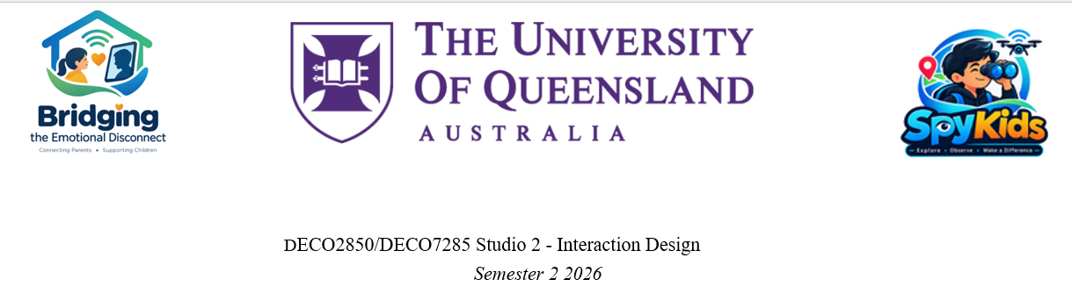

Milestone 2 — Design Exhibit of Iteration 2
Rubric-Aligned Plan

Key facts from the brief
- When: Thursday 29 October 2026, 10am–2pm, during studio — 5 days from 24 October.
- Weighting: 25% of the course.
- Format: an exhibition booth around your table, with all team members present and actively contributing.
- What's expected: a high-fidelity prototype that is close to a final product, with polished look-and-feel, and that includes findings from user evaluation.

How the marks are split
- Overall Presentation (20%)
What earns the High Distinction:
- Excellent visual and verbal communication.
- All questions answered correctly and effectively.
What to show:
- Everyone speaks: each person owns a part of the journey and can explain the "why" behind it.
- Answer questions calmly and openly. The rubric specifically penalises being "very defensive".
- Connection with Field Data & Quality of Prototype (40%)
What earns the High Distinction:
- An excellent connection between user insights and the prototype.
- An excellent demo, where functionalities and user interactions are clear.
What to show:
- A live demo of the full journey:
  - app login → tutorial / user manual
  - onboarding and setup
  - pairing the app with the bear
  - a parent sending care
  - the child receiving it on the bear
- Every feature traced to an insight. This is where the tutor's "care + evidence" rule gets marked. Features with no link to the field data, like coins, streaks, the mood widget, or "Warm", weaken this score — justify them or cut them.
- Design Process (40%)
What earns the High Distinction:
- An excellent poster and flyer that make the project clear.
- Ample evidence of multiple low- and high-fidelity prototypes.
- Excellent improvements in this iteration that come from user evaluation.
- An exceptionally creative and original exhibit.
What to show:
- Poster: the journey from problem → research → insights → v1 → Milestone 1 feedback → evaluation → v2.
- Prototype trail on the table: sketches, storyboards, wireframes, the v1 build and the v2 build, side by side.
- User evaluation results and an improvement list, showing "we found X → we changed Y".
- Originality statement: what makes Baobei different from monitors and smartwatches — two-way emotional connection, not surveillance.

Biggest risk: user evaluation
User evaluation sits inside the 40% Design Process criterion. With no evaluation at all, that criterion drops to the fail band. The brief expects:
- 4–6 participants.
- Each team member engages with at least one participant.
- An output that is a list of improvements based on user feedback.
If some teammates can't take part, run the sessions you can and record honestly who ran each one.
- Deliverables checklist

Required by the brief
Deliverable | Notes
High-fidelity prototype (bear + app) | Polished, working, and demonstrates the full journey
A2 colour poster | Shows the design process, not a feature list. Use the name Baobei
One-page take-away flyer | Product-facing: what Baobei is, who it's for, and how it shows care. Print multiple copies
Exhibition booth | Arranged so a visitor can follow the story left to right
- Evidence on the booth
The tutor's list of supporting documents goes here, printed or shown on a laptop or tablet.
Evidence | Rubric link
Project Plan with schedule | Process, teamwork
Scoping & Data Collection: literature review, digital ethnography, interviews, survey, combined analysis and analysis map | Field data connection
Technical Engineering Procedure v1 | Multiple prototypes
Milestone 1 show & feedback | Iteration
Master Plan Refinement (response to M1 feedback) | Iteration
Technical Engineering Procedure v2 | Multiple prototypes
User evaluation summary + improvement list (add this) | Improvements from evaluation
v1 → v2 change table (add this) | Iteration, visible at a glance
Sketches, storyboards, wireframes | Low-fidelity prototype evidence
All of these also become appendices for the Project Report due 13 November, so the effort pays off twice.
- 5-day plan to Thursday
Day | Focus
Thurs 22 – Sun 25 Oct | - Complete the Bear Engineering  - Lock the feature list against "care + evidence".  - Finish the onboarding and pairing flow.  - Connect the App to Bear
Sun 25 – Mon 26 Oct | Run user evaluation with 4–6 participants. Record findings and produce the improvement list.
Tue 27 Oct | Make at least one or two visible changes from the evaluation. Draft the poster and flyer. Write the v1 → v2 change table.
Wed 28 Oct | Print the A2 poster (book the printer early).  Print the flyers.  Print Project Documentation evidence  Full rehearsal of the demo and the speaking split.
Thu 29 Oct | Set up the booth before 10am. Run the exhibit.

